Policies_Verifying Agency Billed Policy_Instance43_29-May-2018_04-47-03_AM_SingleSignOn.png

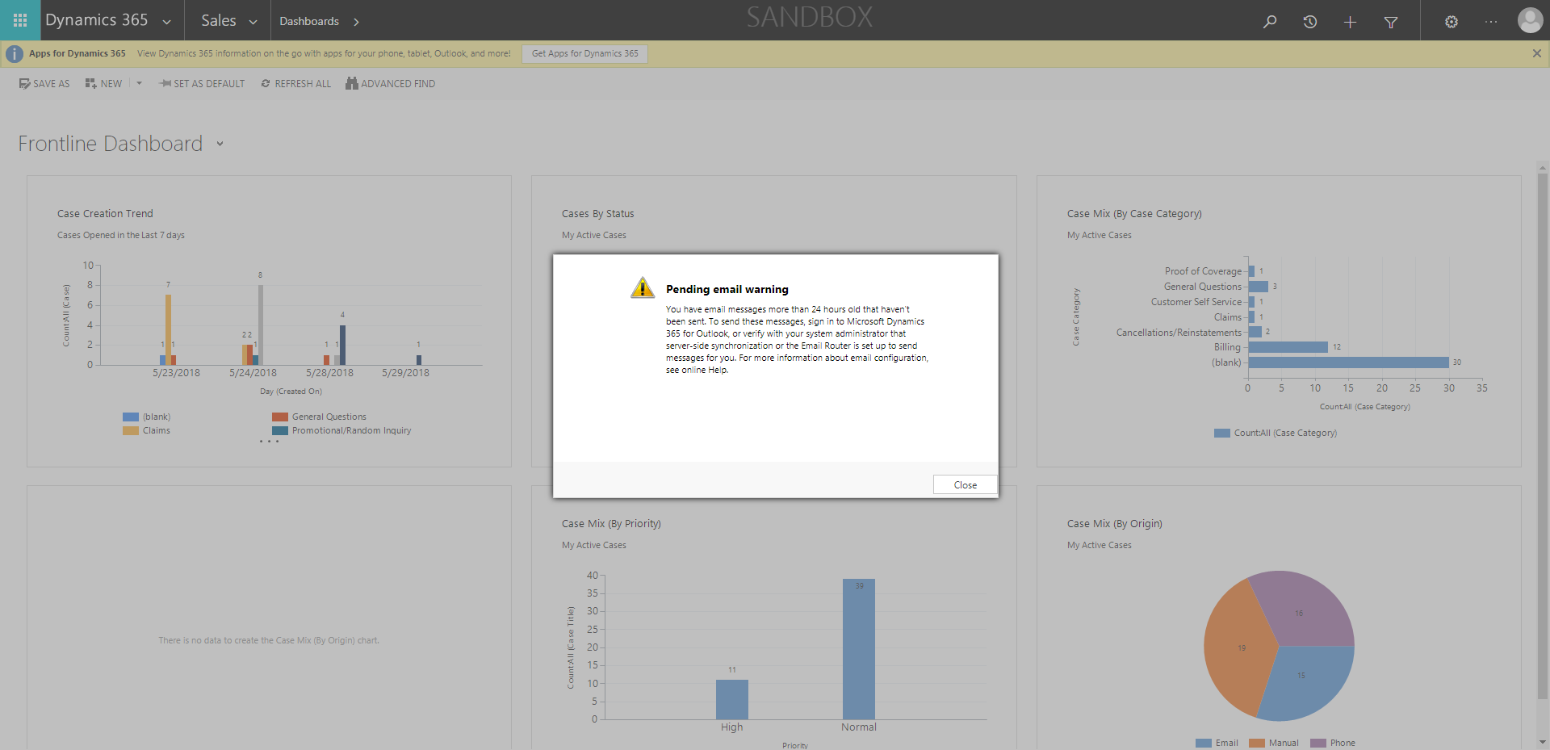

Policies_Verifying Agency Billed Policy_Instance43_29-May-2018_04-46-30_AM_MouseClickActiononStaleElement.png



Policies_Verifying Agency Billed Policy_Instance43_29-May-2018_04-46-33_AM_MouseClickActiononStaleElement.png



Policies_Verifying Agency Billed Policy_Instance43_29-May-2018_04-47-29_AM_ValidationofAgencyBilledPolicy.png

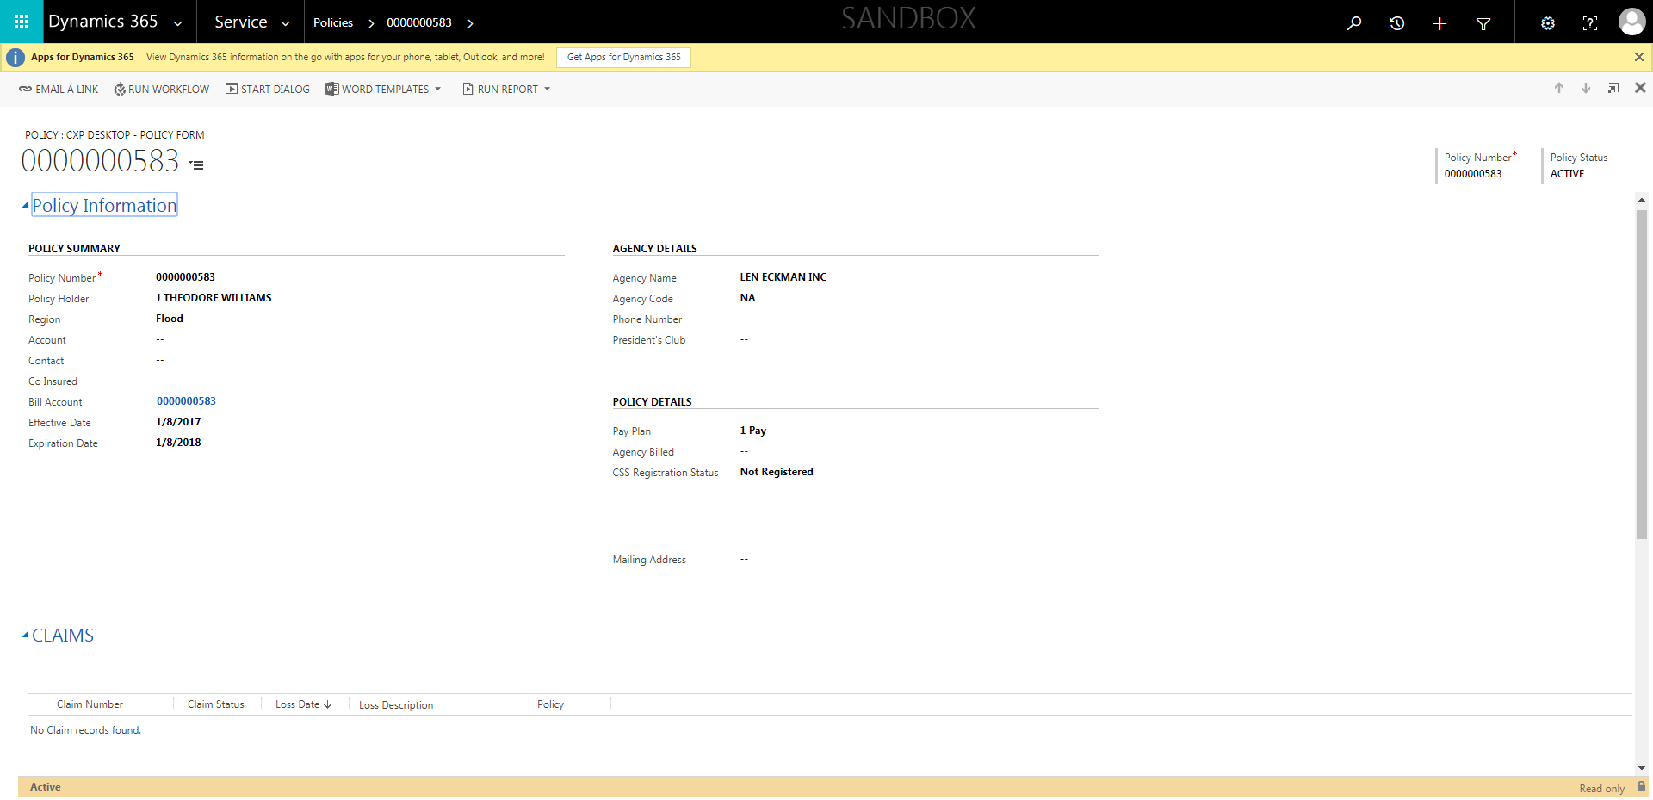

Policies_Verifying Agency Billed Policy_Instance43_29-May-2018_04-47-23_AM_ValidatingPolicysubentitynavigation.png

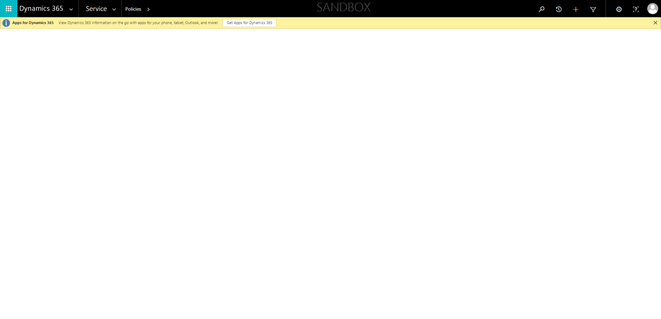

Policies_Verifying Agency Billed Policy_Instance43_29-May-2018_04-47-19_AM_ValidatingPolicyentitynavigation.png

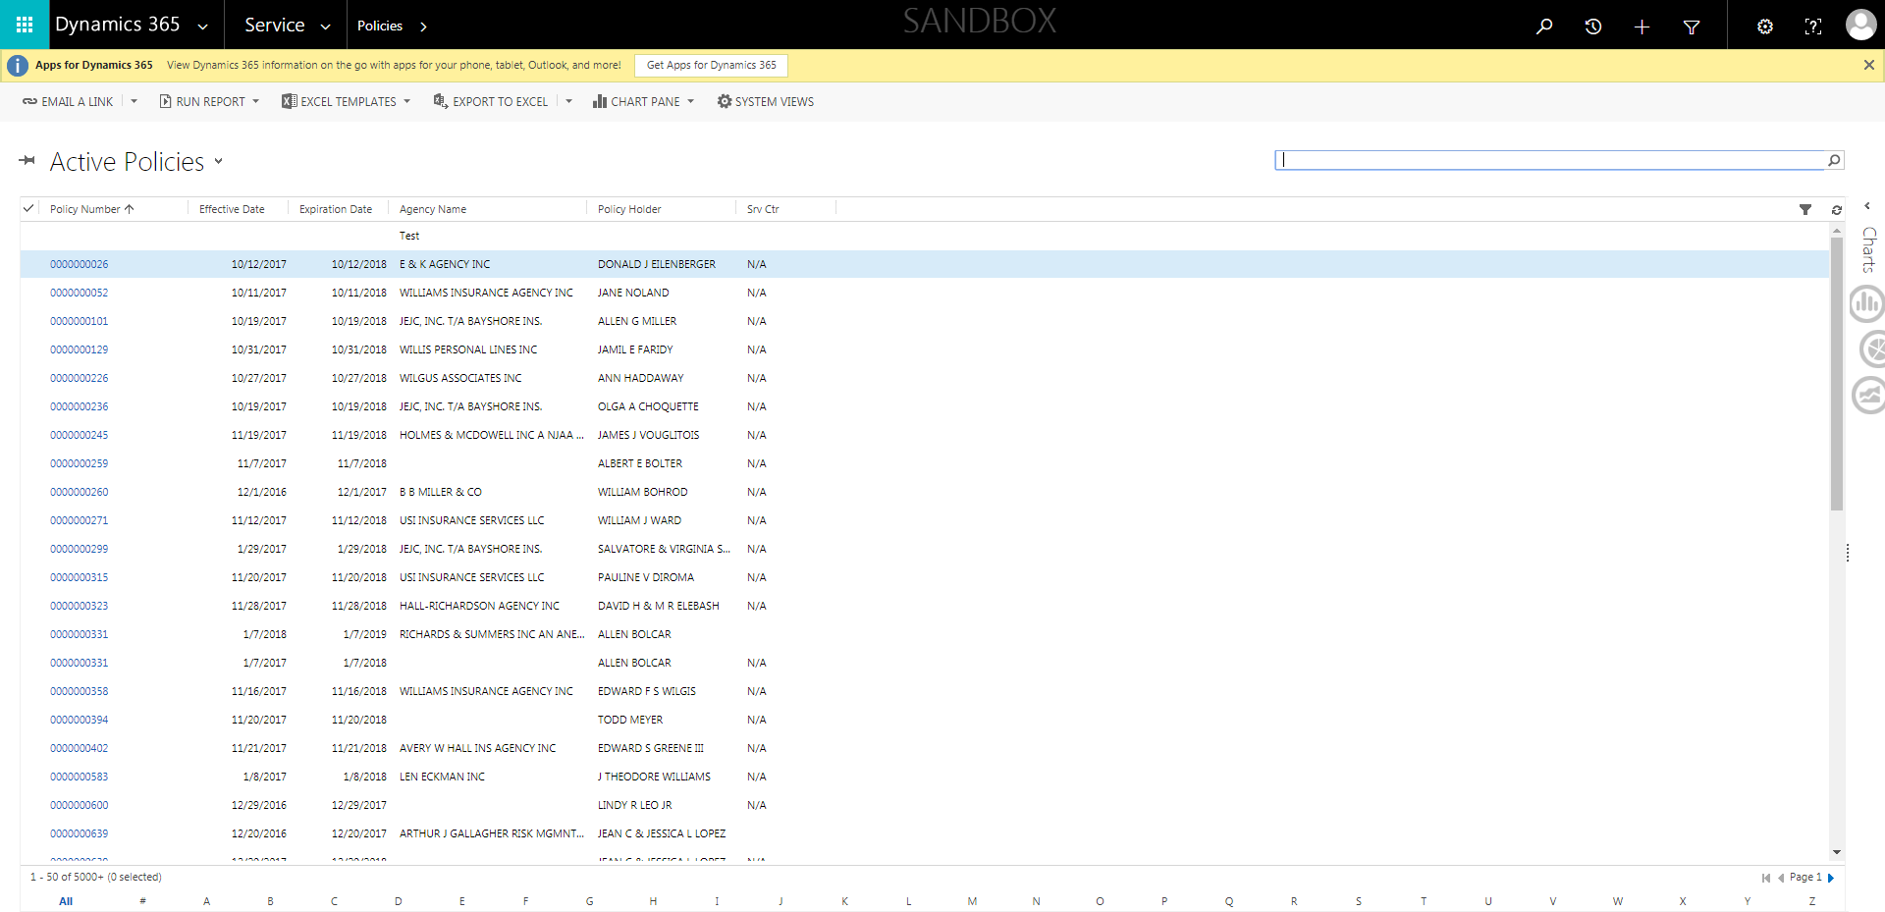

Policies_Verifying Agency Billed Policy_Instance43_29-May-2018_04-47-09_AM_SingleSignOn.png

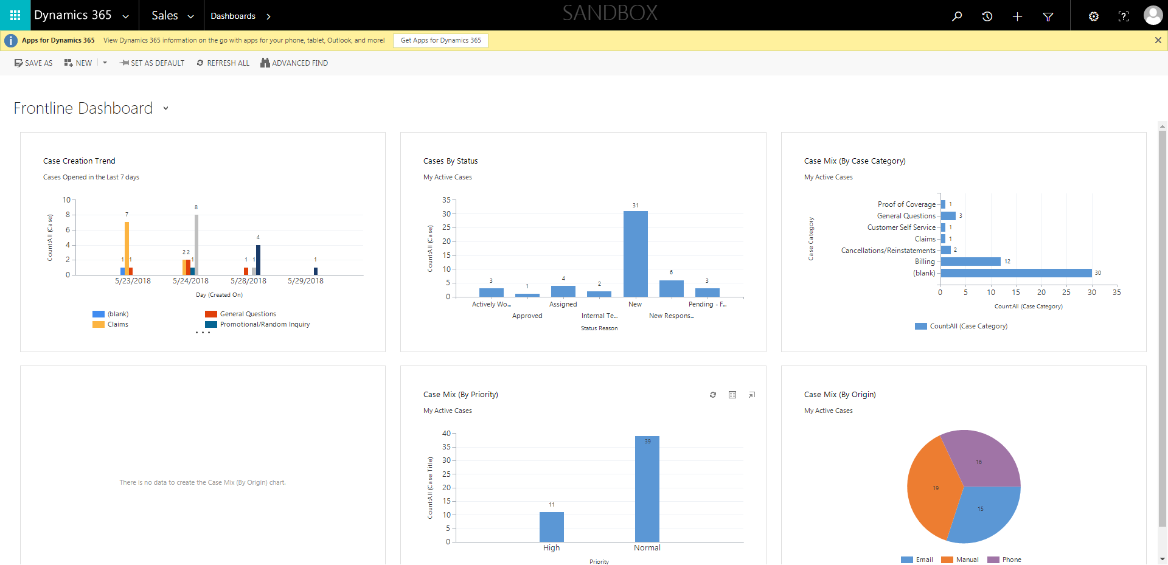

Policies_Verifying Agency Billed Policy_Instance43_29-May-2018_04-46-32_AM_EnterTextAction.png

